Test Plan - Group 16

“A document listing game or player actions that need to be tested as well as their expected actions. This test plan will be modified throughout the project as new functionality is added to the game. Make sure that your document clearly labels each milestone.”

Milestone 1

Milestone 2

| **Action/Test Item** | **Expected Result** |
| --- | --- |
| **Game Controls** | |
| W Key | Move up |
| A Key | Move left |
| S Key | Move down |
| D Key | Move right |
| F Key | Interactions (Picking up items, Enter/Leave Grotto) You must be beside the object to interact |
| R Key | Restart game at forest with inventory persisted and renders the welcome screen |
| Esc | Exit game |
| T Key | Toggle tutorial on and off, starts at welcome and movement step |
| N Key | Skips to next step of tutorial if it isn’t complete |
| Left Click | Select an inventory slot, throw ammo |
| Number Keys 1-8 | Select inventory slot |
| Left Click and Drag | Interact with potion making menu, moving the ladle, adjusting heat knob, stirring the cauldron |
| **Game Mechanics** | |
| Item Collection and Respawn | Find a Magical Fruit (orange and grows on trees) or a Coffee Bean (brown and grows on bushes), press F to pick it up. Item should disappear, then after 1-5 seconds, it will respawn in the same location. |
| Textbox Visibility | Textbox will appear/disappear when the player is close/far away to an item. Textbox will disappear after the item is picked up. After item respawn, the textbox should be restored too. |
| Collisions | * Player can walk across the bridge, and can move around the shape of the bridge with mesh based collision detection * Player cannot exit the bounds of the game or into rivers. * Player cannot walk through the tree trunk, but can walk through and behind the leaves. * Player collides with various objects in the grotto. * Enemies collides with the same terrain items as the player |
| Biome Switching | Interact with an entrance/exit - the screen should fade while maintaining the same background, and the screen will fade back in with the player in the new biome. Character movement should not be possible during this process, essentially the screen should be frozen. |
| Combat | * When the player has selected an ammo item (fruit) in the inventory, they can left click to throw the ammo in that direction. The player has a max throw radius as well as a throwing cooldown of 1 second. Throwing one ammo will remove one count of the item from inventory. * Enemies have a set health and ammo has a set damage. On ammo-enemy collision, the ammo will disappear and the enemy’s health will drop by the amount of the ammo’s damage. If the enemy’s health drops to 0 or below, it will also disappear and a collectable enemy drop will be created at the same position. * If player collides with the enemy, the game will restart |
| Potion Making | * Follow the tutorial for potion making |
| Tutorial | There are different steps of the tutorial to guide the player upon starting a game (see suggested game test plan). Completion of one step will trigger the next step’s text box. Pressing T will toggle the tutorial on and off, defaults to on. Pressing N will skip to the next tutorial step. |
| Data Persistence | Items in the player inventory will automatically be persisted for next game loads. |
| Enemy AI | * Enemy behaviour uses decision tree logic with four states: Attack, Wander, Return, and Idle. * Collision handling to prevent enemies from getting stuck. * State transitions:   + Attack: Enemy chases when the player enters detection range.   + Wander: If the player escapes, the enemy moves randomly for a short time.   + Return: After wandering, the enemy moves back to its spawn point.   + Idle: Once back, the enemy stays still until the player enters range again. |

Suggested Game Test Plan:

1. Ensure that you run the game with the instructions in the README
2. Player should spawn at the entrance of the grotto in the top right, with the tutorial steps provided. There is a fps counter in the game window title.

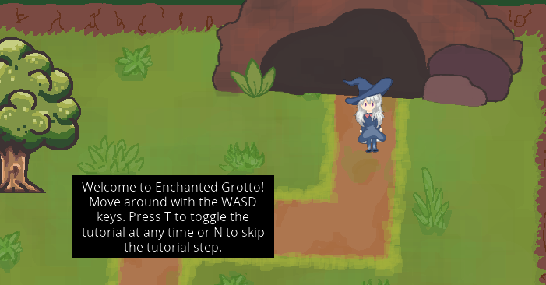

1. Use the WASD keys to move to the trees on the left and bottom. You should see a textbox with “F to interact” appear when you are next to a tree with a fruit on it.

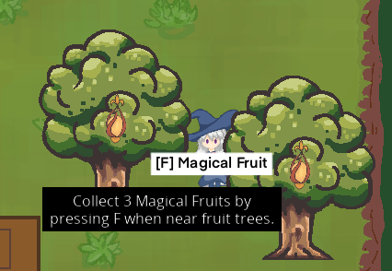

1. Press F to collect fruit on trees. Fruit will respawn after a random time. Observe that the text in the window header updates with your inventory items.
2. Notice how the collision handling allows the user to walk behind and in front of the tree as the rendering layers update.

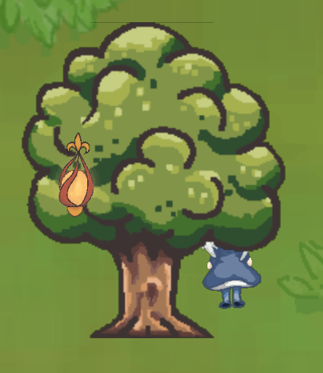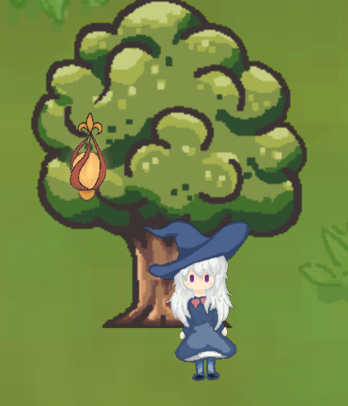

1. Head over to the bush next to the river, collect some of the coffee beans, which have the same random respawn and inventory update as the magical fruit.

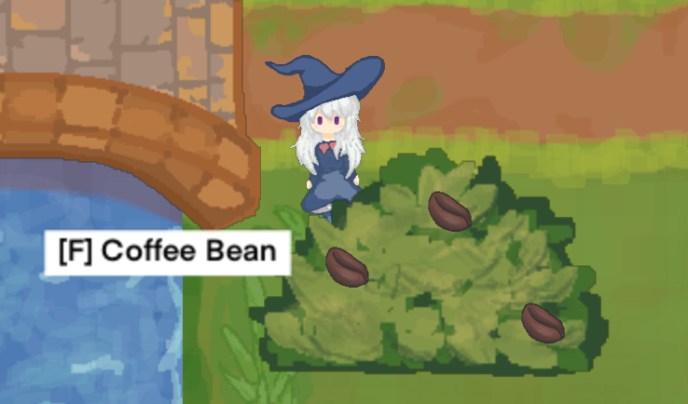

1. Select the fruits by clicking the corresponding inventory slot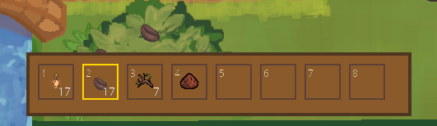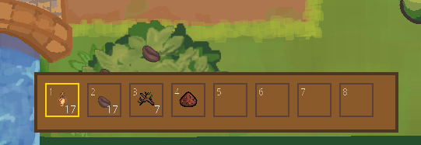
2. Check out our bridge by walking across it, and try out walking along the bridge. The bridge boundaries are now defined by a mesh, so that the player bounding box cannot intersect with the top and bottom of the bridge as defined by the white mesh space illustrated below

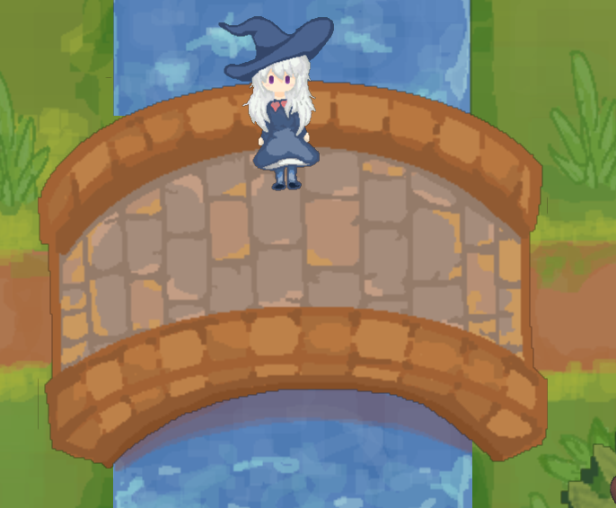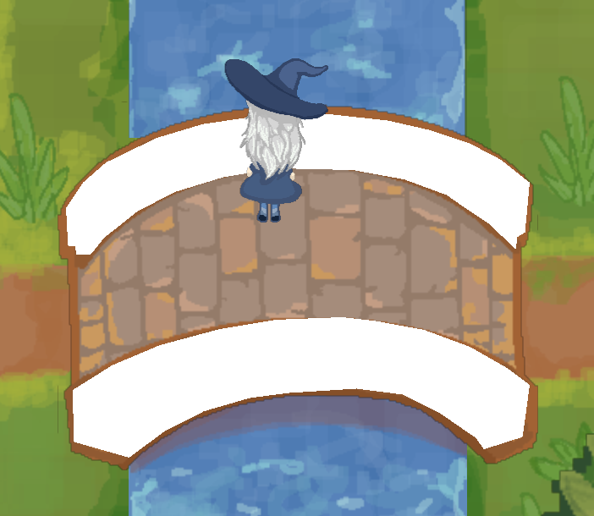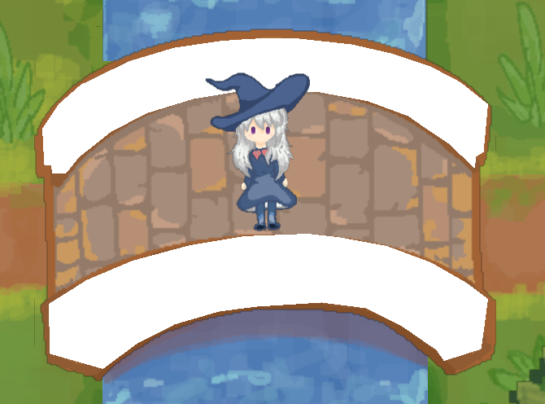

1. Left-click to throw a fruit at the enemy from your inventory, keep throwing to defeat them. When defeated, the enemy will drop an item—collect it to add it to your inventory.

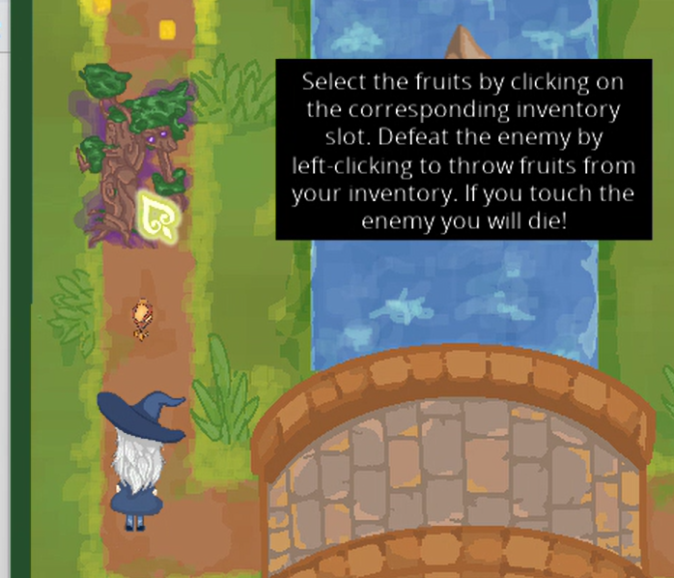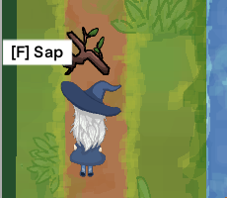

1. Head back to the grotto entrance and click “F” to enter the grotto. Notice the nice fading transition as you go from the forest into the grotto.

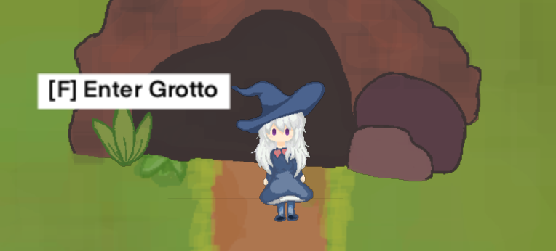

1. Press F while standing in front of the cauldron to open the potion-making menu.

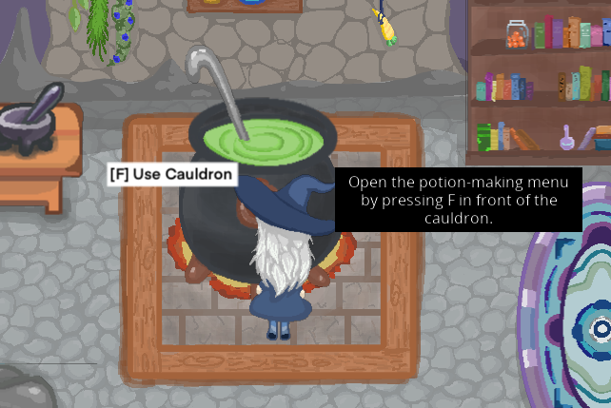

1. Here's what the potion-making menu looks like: there's a knob to control the heat, a ladle to stir the liquid, and a bottle to collect the potion.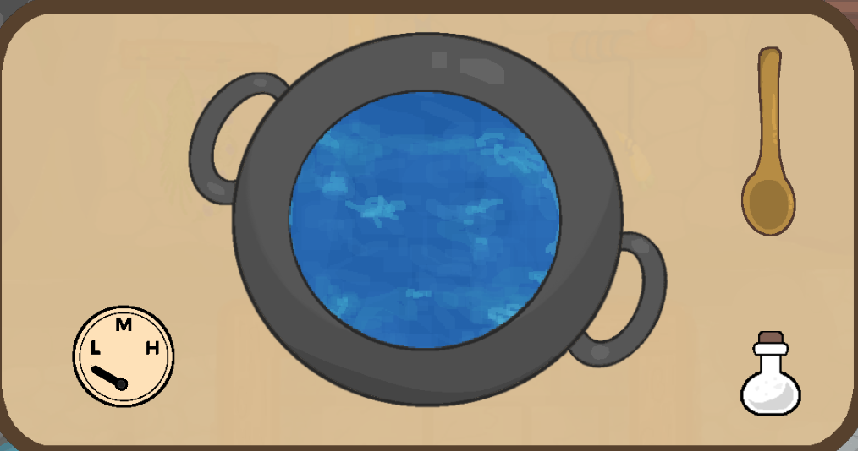
2. Click on the ladle and bring it to the cauldron. Then, click and drag it in a circle to stir.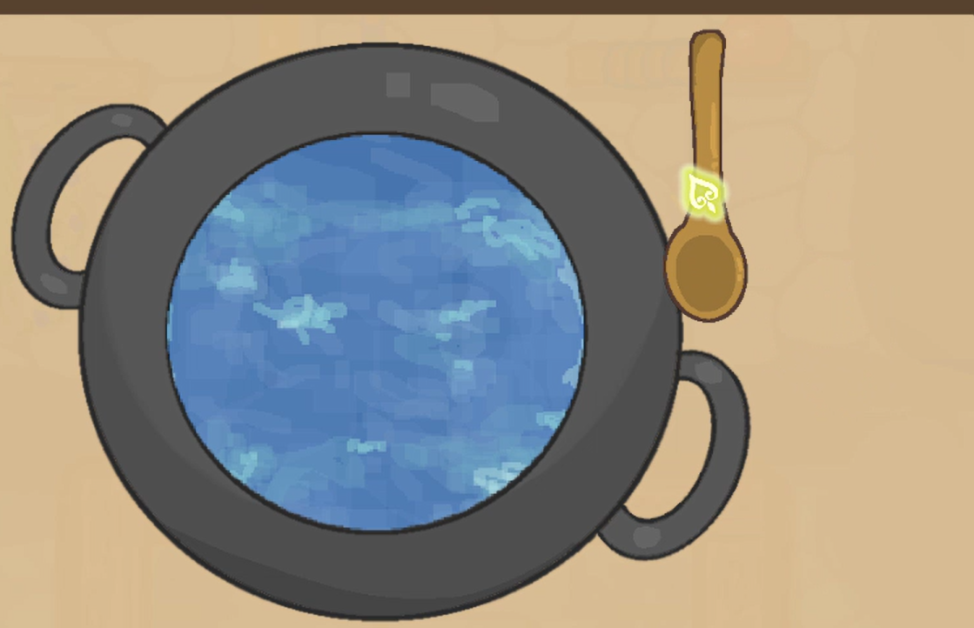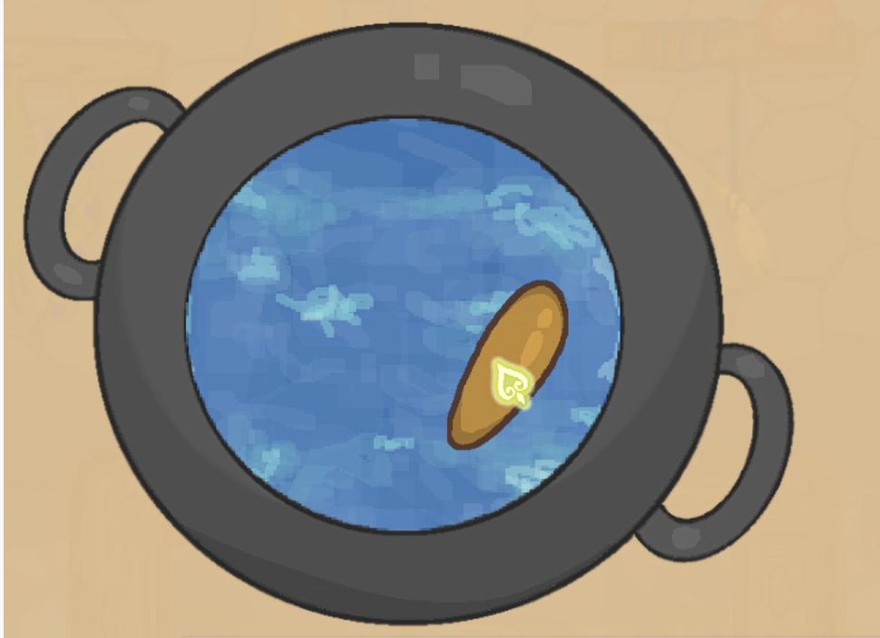
3. Adjust the heat by turning the heat knob

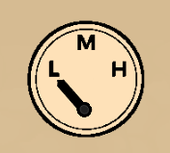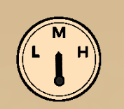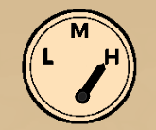

1. Click on the empty potion bottle and drag it to the cauldron to collect the potion.

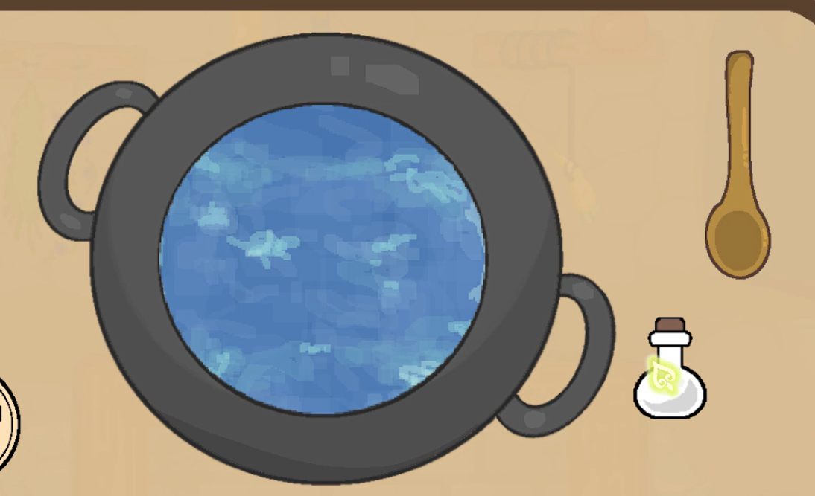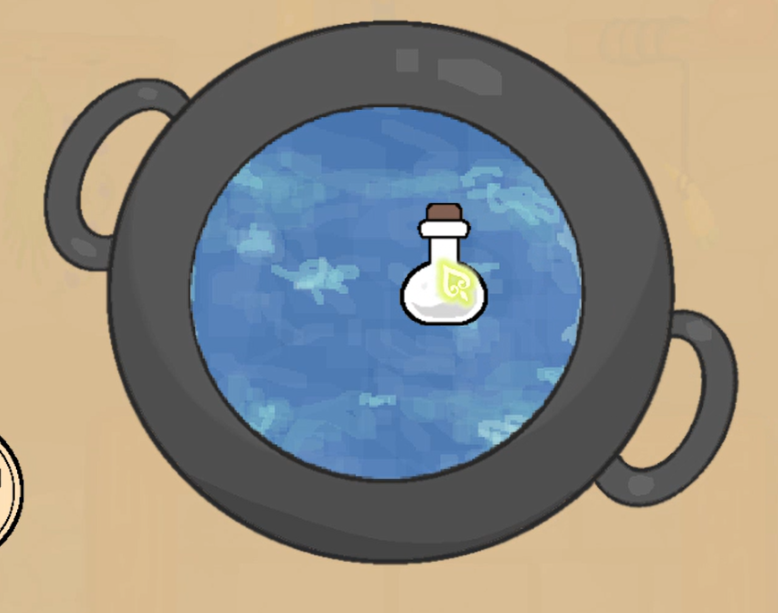

1. Now, try to make a potion by following this recipe:
   1. Adjust the heat to HIGH
   2. Wait for 10 seconds
   3. Add 5 coffee beans
   4. Add 3 magical fruits (water in cauldron will change color :))
   5. Stir 3 times
   6. Wait for 60 seconds
   7. Bottle the potion
2. Press F to exit the caldron menu.
3. Exit the grotto, head to the desert from this entrance in the forest, press F to enter.

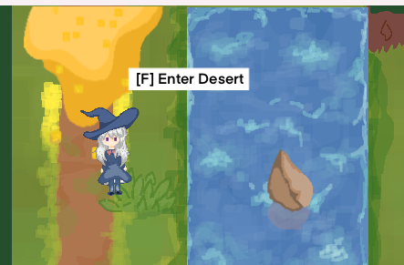

1. In the desert there are 2 mummies, they will start chasing when the player gets too close.

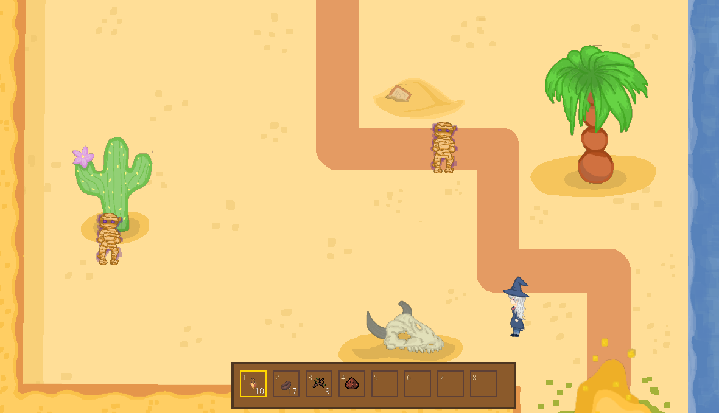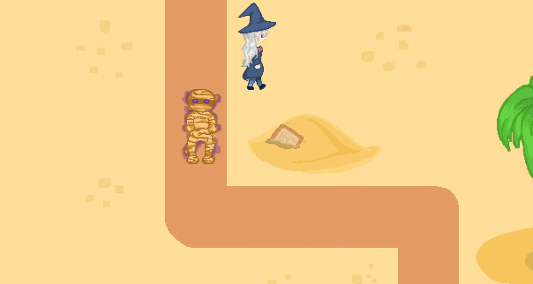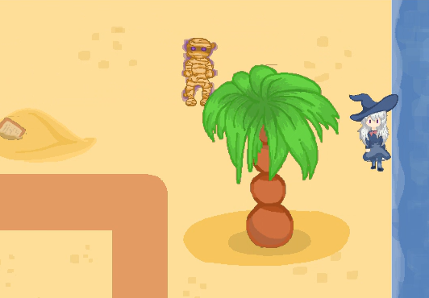

1. Notice if the player moves out of the enemy's range, it will wander around for a few seconds before returning to its original position.
2. Defeat the mummy by left clicking on the screen with ammo selected (your potion), and it will drop magical dust. Press F to pick it up.

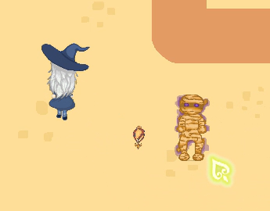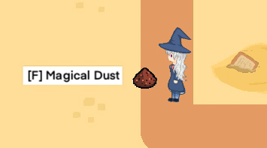

1. Exit the game with ESC, rerun the game and the window header text should indicate inventory persistence, so the items you collected in the game state remain.